* -: In the last video, we added a couple of pipes, the uppercase pipe to transform the instance type and the date pipe to transform the type.
* But as mentioned at the end of the last video it would be nice if we could configure a pipe because this layout here, this way of displaying the date might not be the layout, the format of the data you want to output.
* So it would be nice if we could parameterize a pipe.
* And we can, for example, on the date here, we can add a parameter to configure the pipe by adding a colon.
* And this is the case for any pipe.
* You configure it, you pass a parameter to it by adding a colon, of course the pipe needs to be able to handle a parameter.
* And again, I will come back to where to find out how these pipes work or what the bolt and pipes do, how they can be configured, in a second.
* The date pipe can take a parameter and we simply add it after this colon.
* *Now the date pipe expects to receive a string parameter.*
* So let's pass a string.
* And there you basically set up the date.
* I'll come back to the options you have in a second.
* Now, for a moment, let's just enter full date camel case.

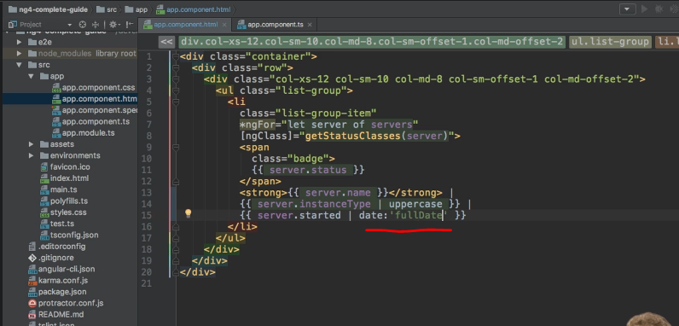

* So a capital D.
* Let's save this and go back to our application.
* And you see, now we get a better formatted date.

* Now might still not be what you want, but again I will come back to our options in a second.
* It is what I like to see here, and this is how easy you can parameterize a pipe.
* You can pass parameters by simply adding a colon and then the parameter.
* As a side note, if you would have multiple parameters here, you simply separate them with additional colons.
* So the date pipe doesn't take an additional parameter but if it would, you could pass it by adding another colon and then the second parameter.
* Now with these basic functionality set let's have a look at where you can learn more about the built-in pipes and how you can configure them.
* Let's dive into this in the next lecture.